Supervised Machine learning : [Regression and Classification] :

There are various machine learning algorithm but the main 2 algorithm here are :

1 ) Supervised learning algorithm : A type of machine learning where the model learns from labeled data (input-output pairs) to **predict outcomes** for new data.

2 ) Unsupervised learning algorithm : A type of machine learning where the model learns patterns and structures from **unlabeled data** without any predefined output.

Example of supervised learning:

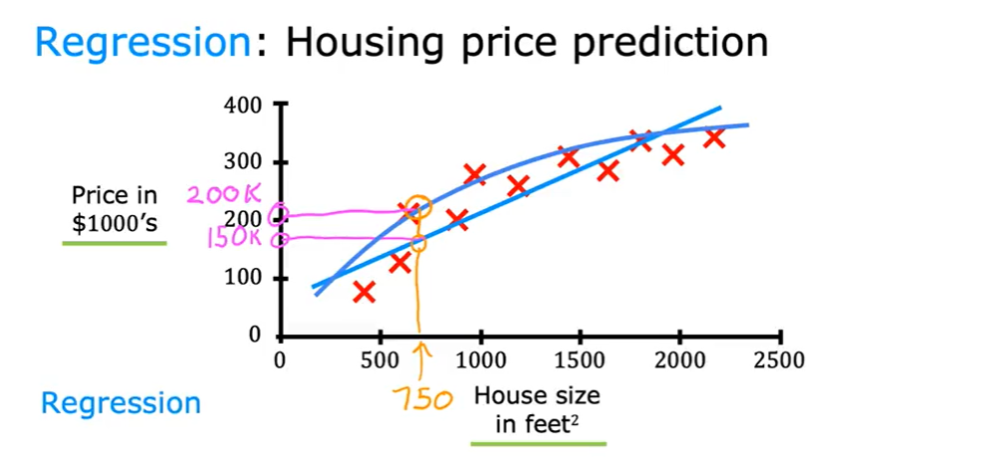

Supervised learning can be used for 2 types :

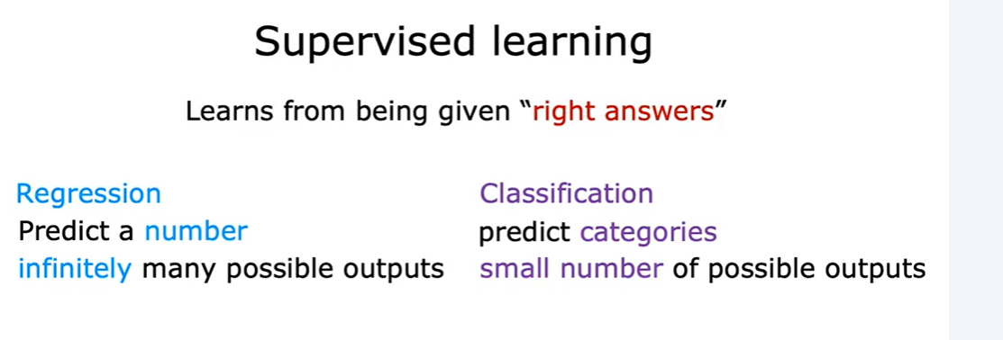

Supervised and Unsupervised difference :

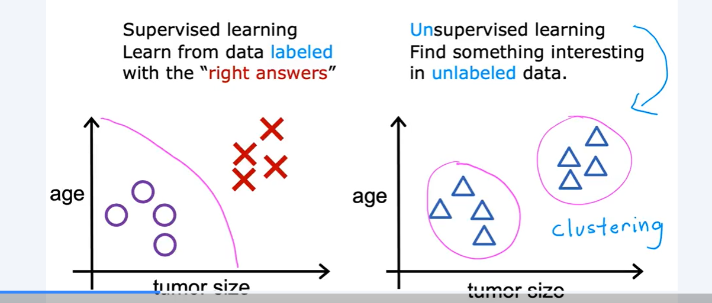

Example of unsupervised learning algorithm:

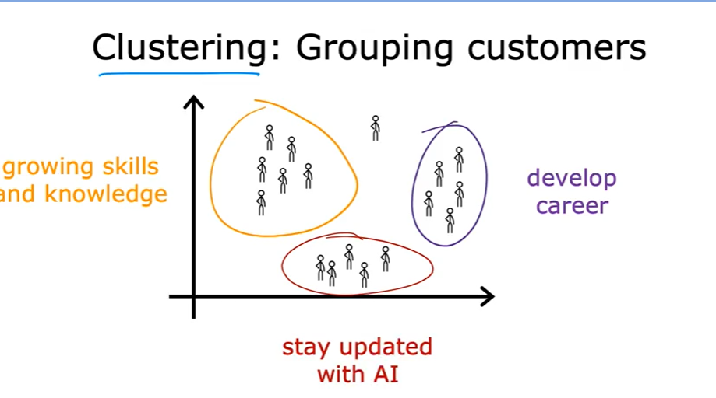

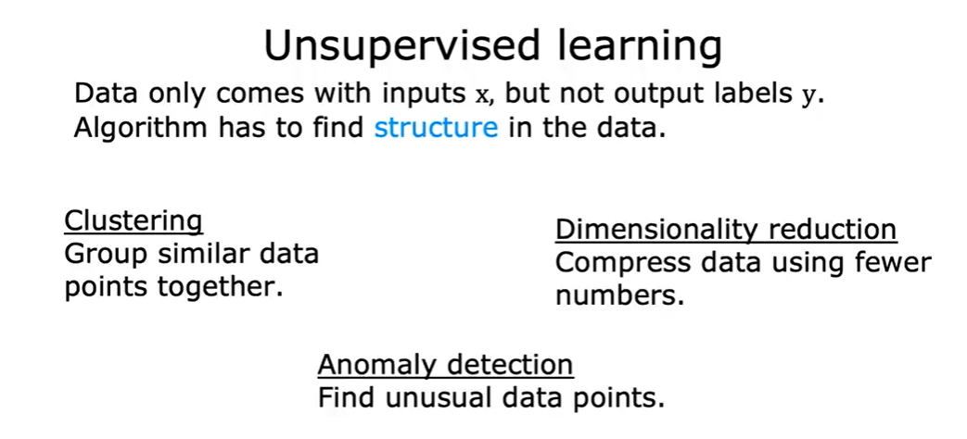

Supervised learning:

1) Regression:

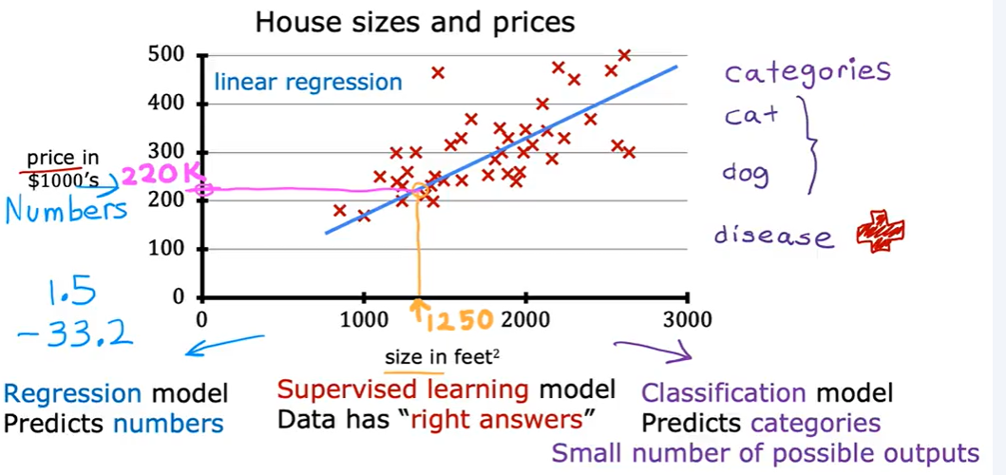

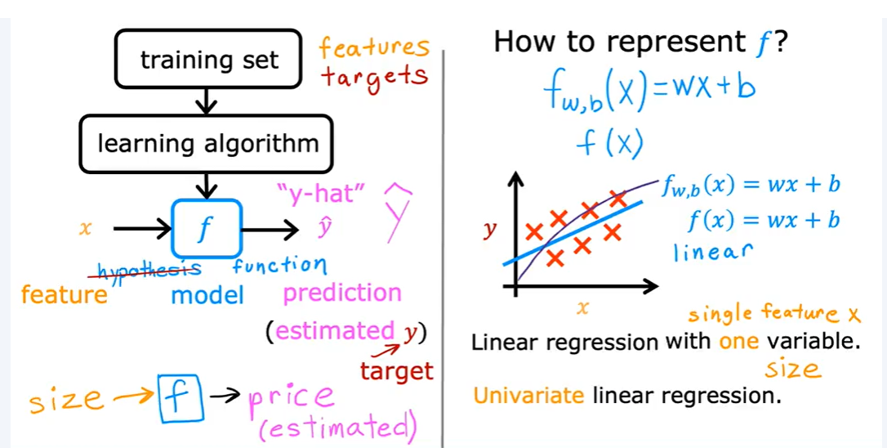

Fitting regression line on various condition :

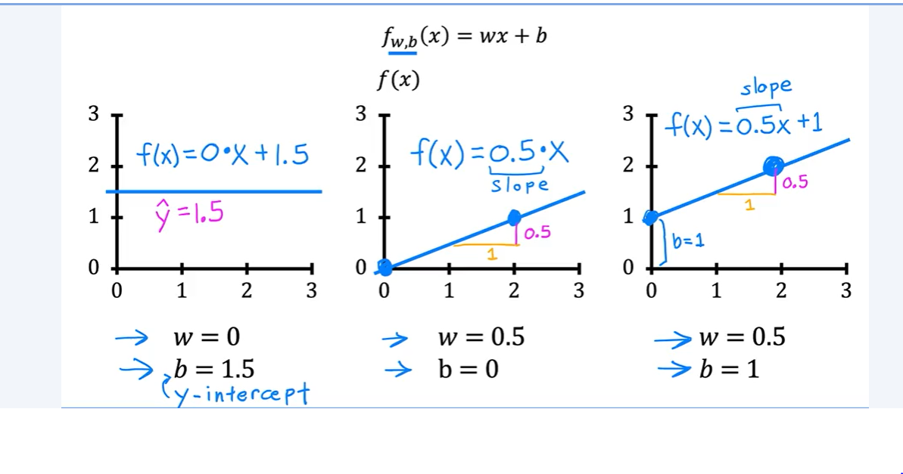

Here the cost function is used to observe how well our data fits the model.

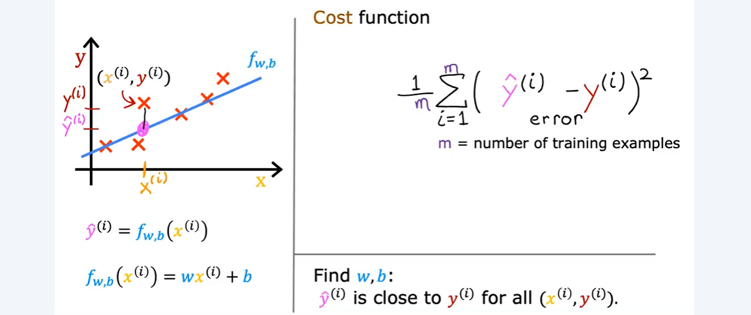

In machine learning people uses different cost function for different purposes but squared error cost function is most common and mostly used for regression task

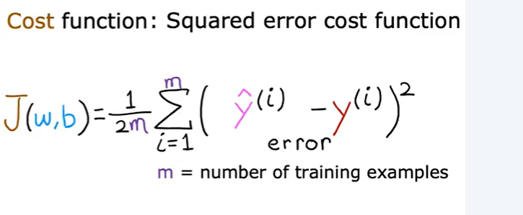

By convention the cost function that people uses is divided by 2*m , the extra division of 2 just meant to make some of our later calculation clear .

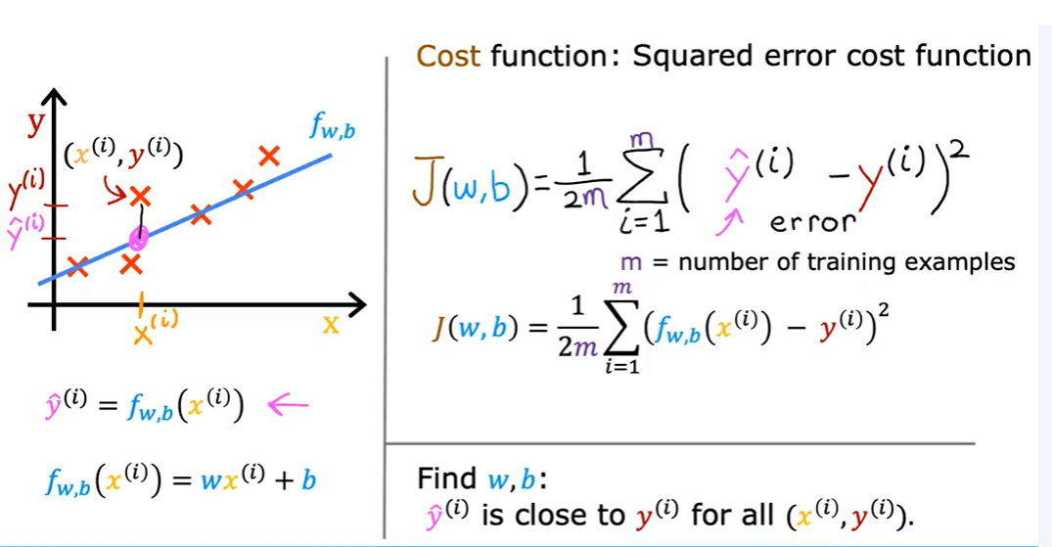

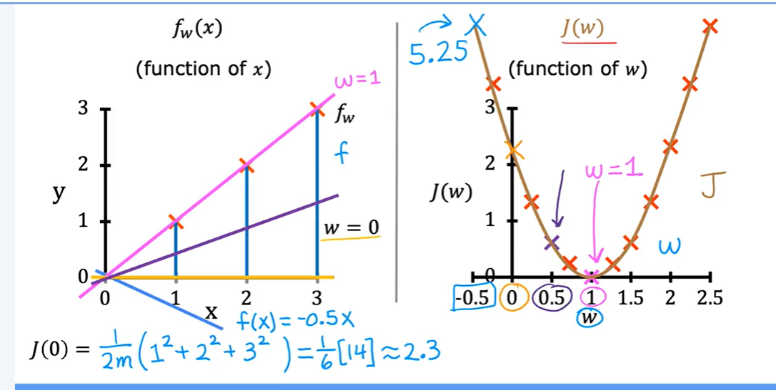

Each value of parameter w corresponds to a different straight line fit. f(x) on the graph to the left. And for given training set that choice for w corresponds to a single point o right

Because for each point of w the cost can be calculated as J(w) .

**❓⭐How can the proper value of w be chosen so that the fitting of the line is well?**

**Ans:** Choosing a value of w that minimizes the squared error as small as possible gives a good model.

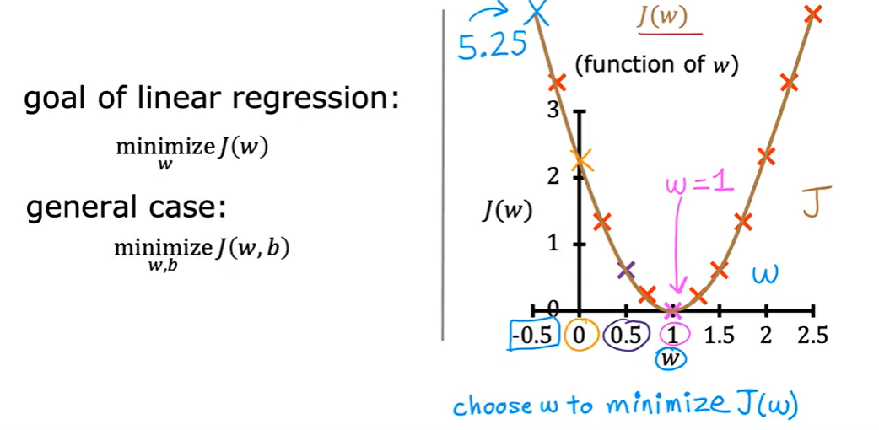

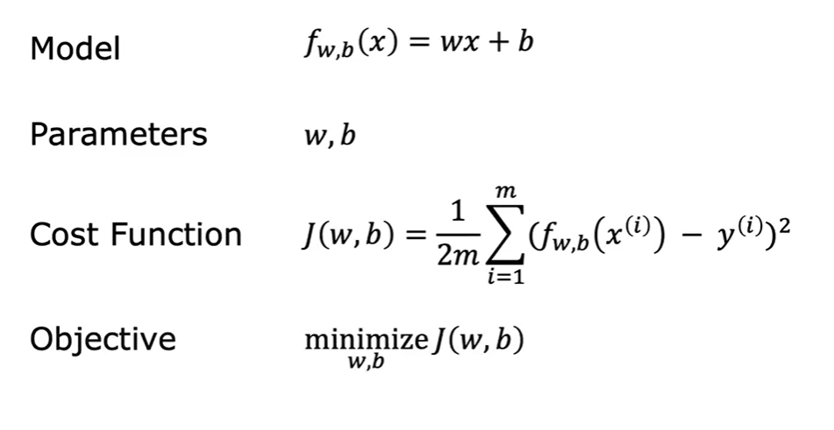

**Gradient Descent**:

Gradient Descent is a method to find the best solution (like the lowest error in a machine learning model) by taking small steps in the direction that reduces the error the most.

**Why is it used in Machine Learning?**

In ML, we often have a **loss function** (how wrong the model is) and we want to minimi

-ze it. Gradient Descent helps us adjust the model’s parameters (like weights) to reduce

the loss.

**How It Works (Steps):**

* **Start with random parameters** (weights).
* **Compute the gradient** (slope) of the loss function.
* **Update the parameters** in the direction that reduces the loss.
* **Repeat** until the loss is minimized.

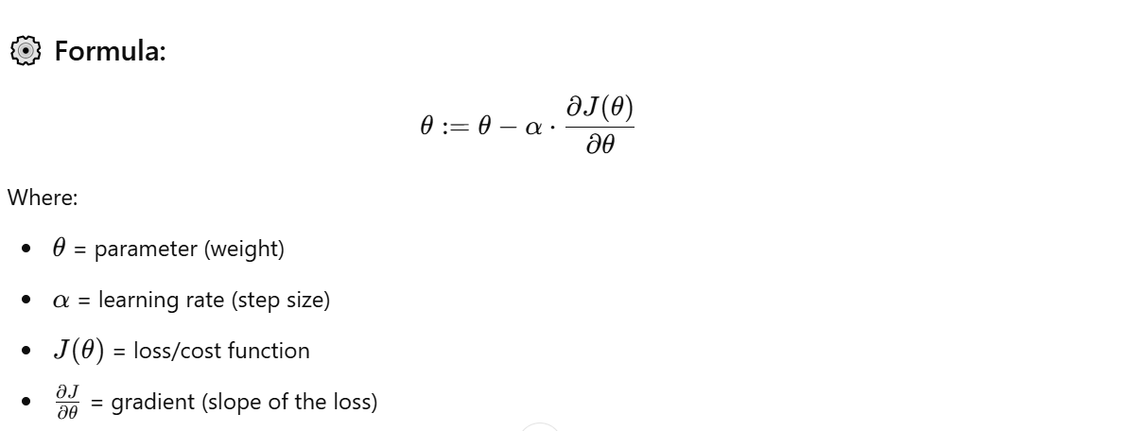

Here , alpha is the learning rate which determines how big step it will take to update model’s parameter.

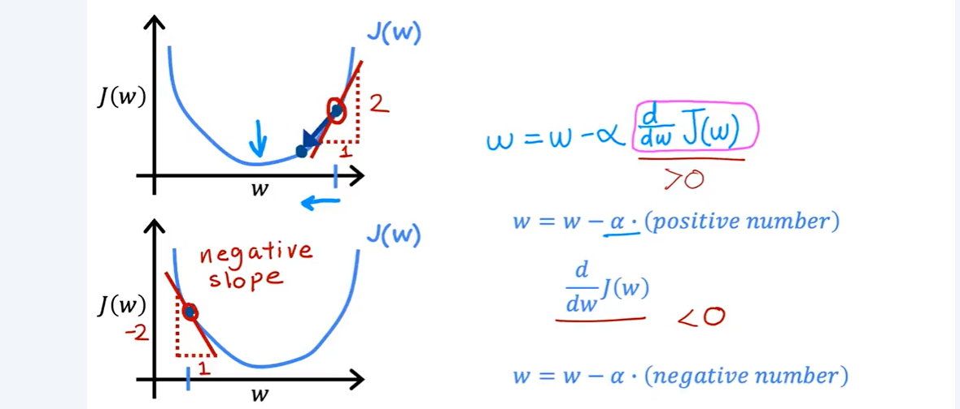

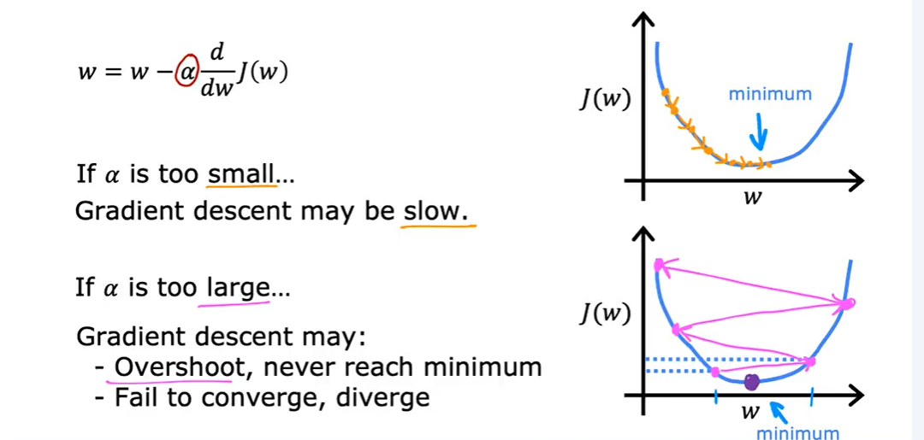

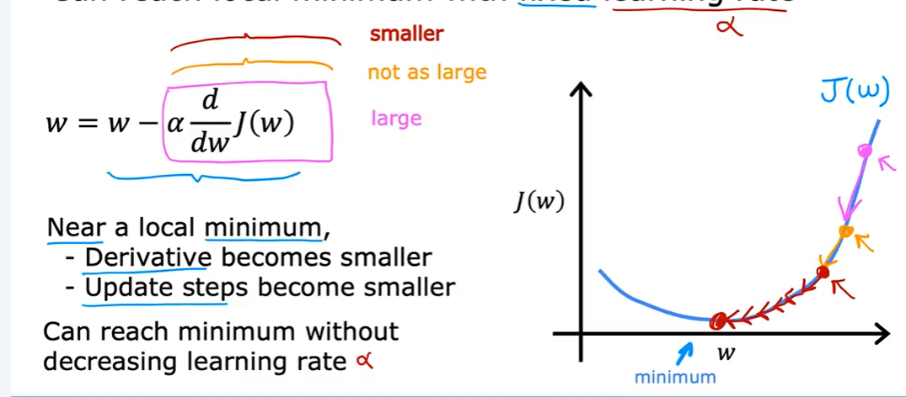

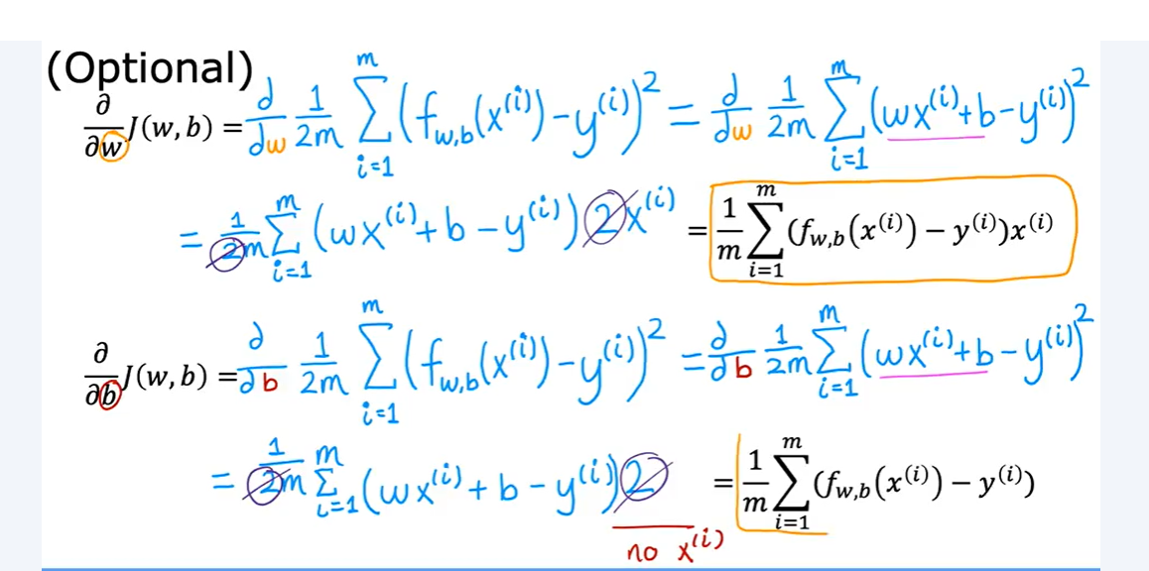

Differentiate with respect to w and b and after differentiation the result of gradients are found .

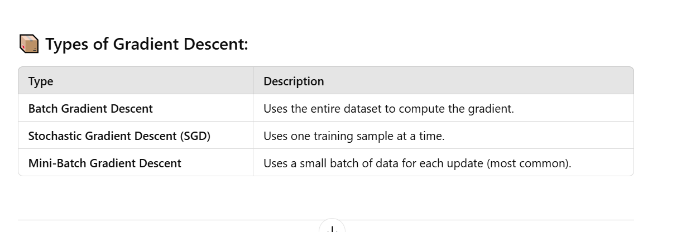

Multiple Linear Regression:

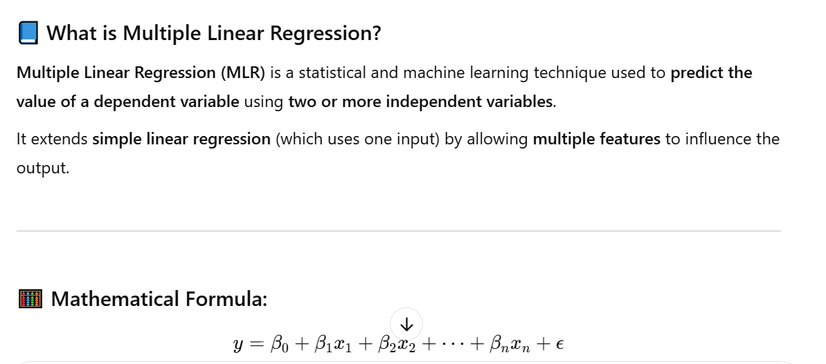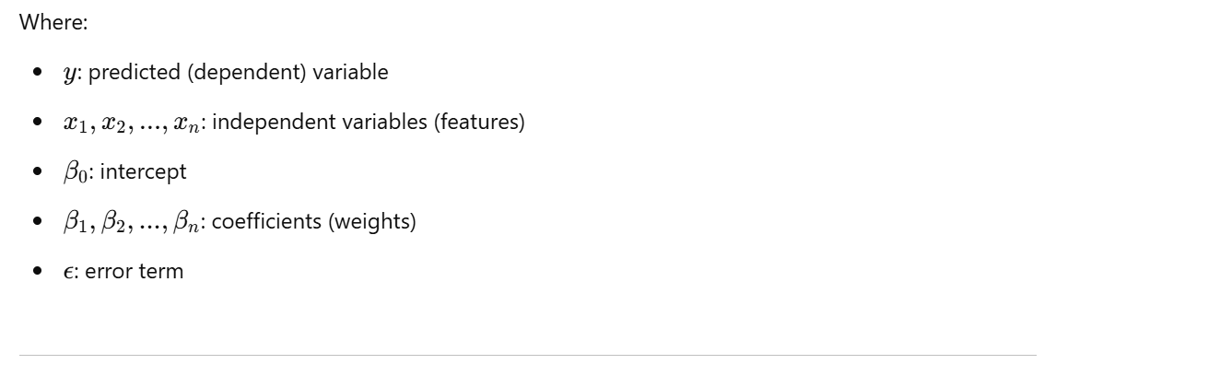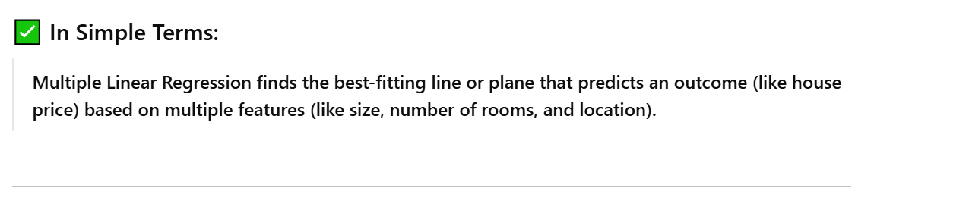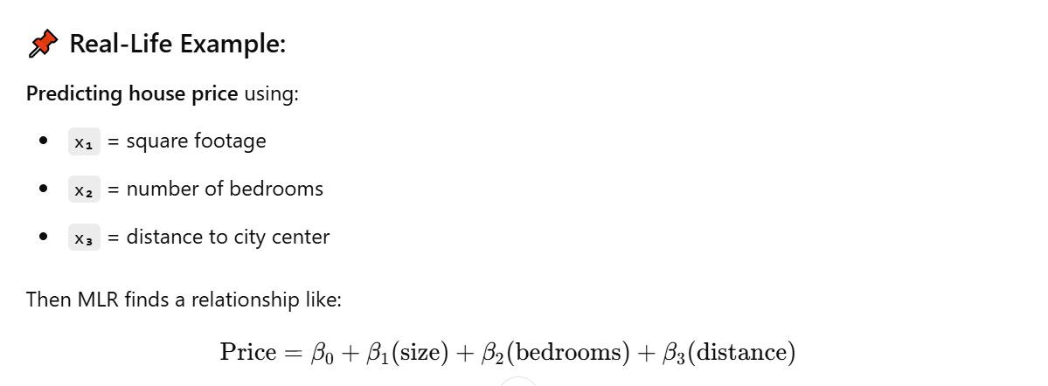

Vectorization:

**Vectorization** is the process of converting operations (especially mathematical computations) into **vector or matrix form** so that they can be executed efficiently using **optimized low-level implementations** (like NumPy or BLAS).

In simpler words , Vectorization is about **removing loops** and using **arrays/matrices** to perform faster, cleaner, and more efficient computations.

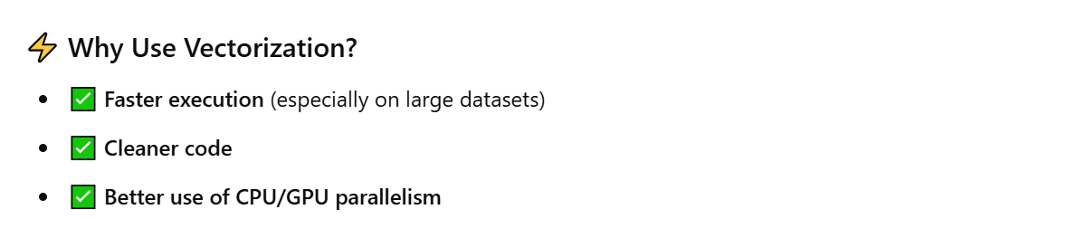

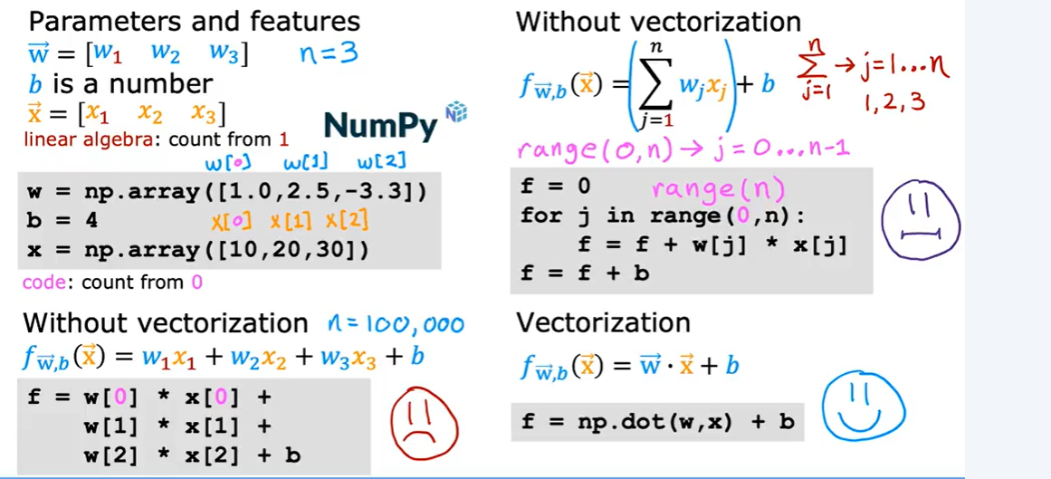

Gradient descent for one feature is simple. The equation is given below:

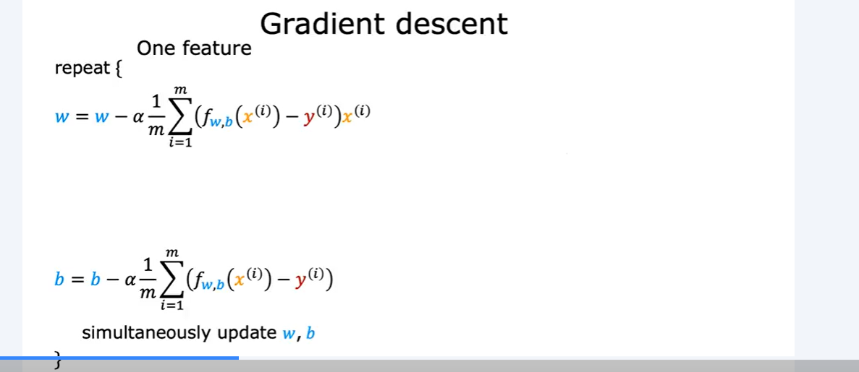

When gradient descent for multiple variables is needed then with respect to each feature variable the differentiation is done and the weight of each feature gets updated.

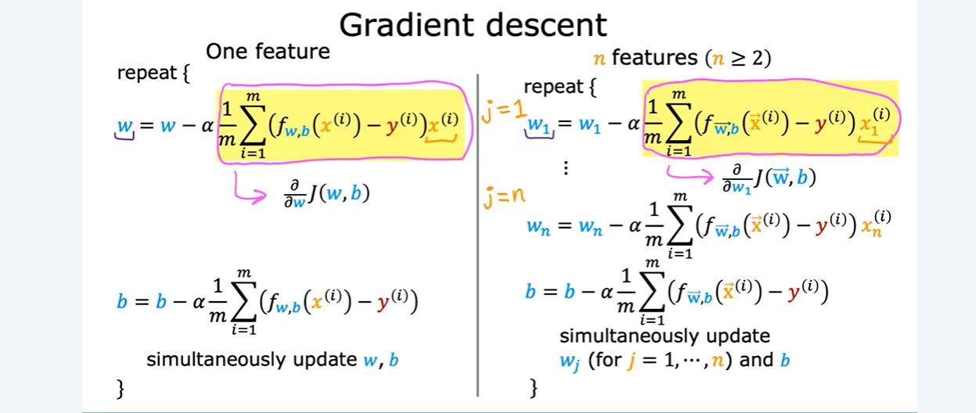

Feature Scaling:

**Feature Scaling** is a preprocessing technique used in machine learning to **normalize the range of independent variables (features)**. It ensures that **no single feature dominates** others simply because of its scale.

Many algorithms (like Gradient Descent, KNN, SVM, PCA) are sensitive to the **magnitude of features**. For example:

* Age (in years): 25, 30, 35
* Income (in dollars): 40,000, 60,000, 80,000

Without scaling, **Income** dominates due to larger values.

With feature scaling , anyone often get gradient descent to run mush more faster.

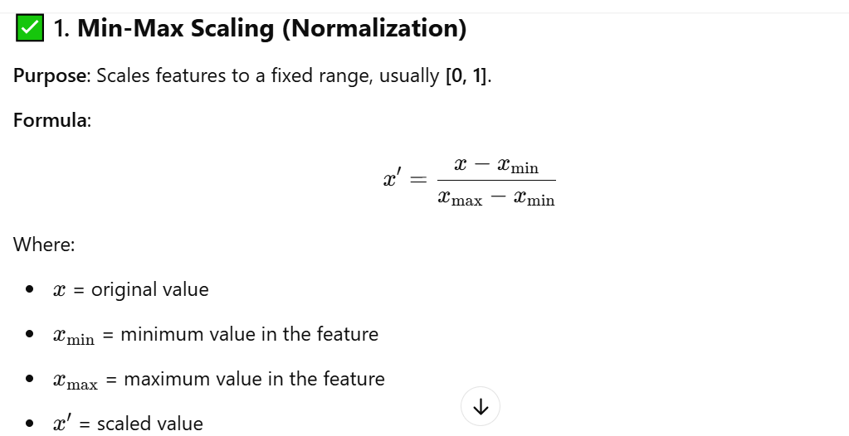

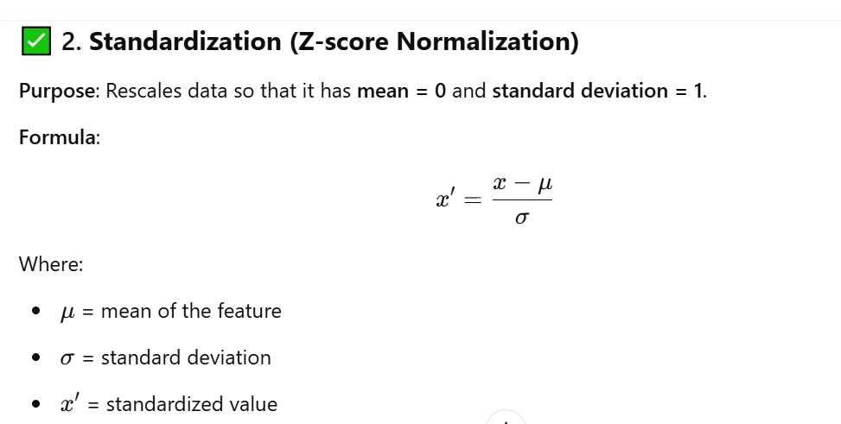

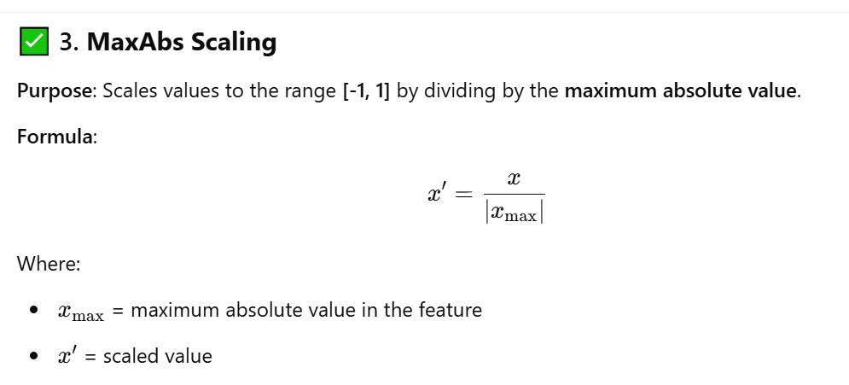

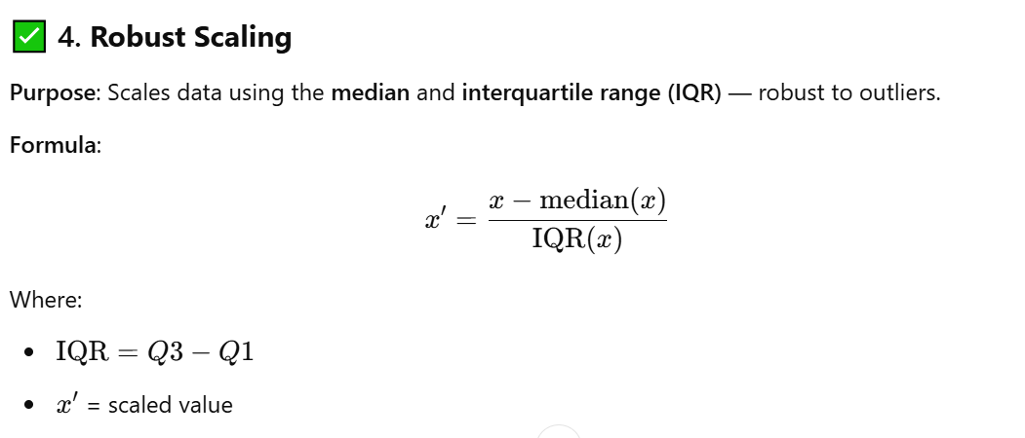

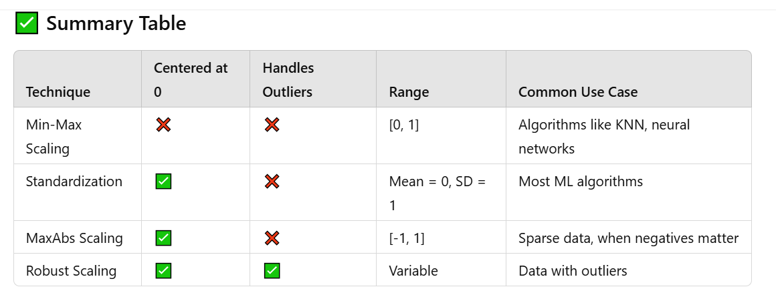

Checking Gradient Descent For Convergence:

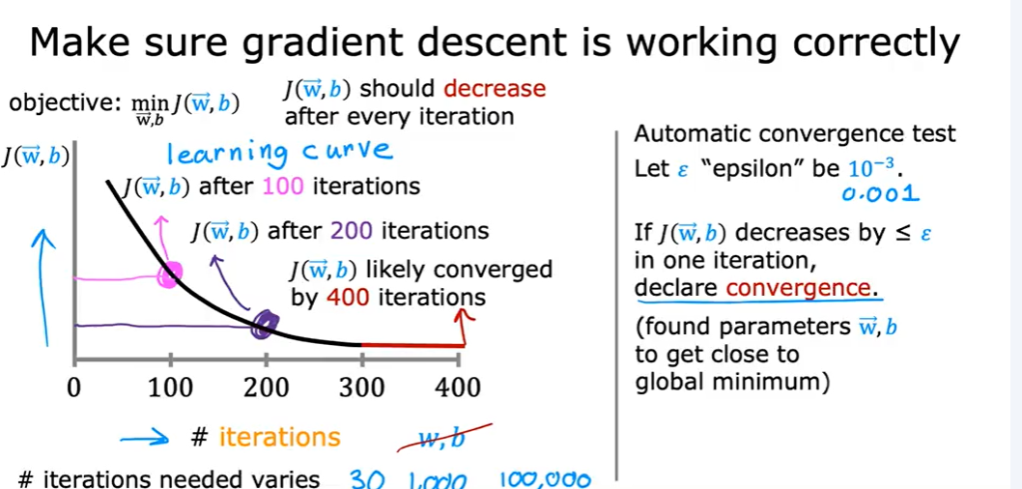

If the cost function gradually decreases with respect to iterations then this is a proof that gradient descent is working and after a fixed iteration when a flat line is derived that means that it converges.

Choosing Learning Rate:

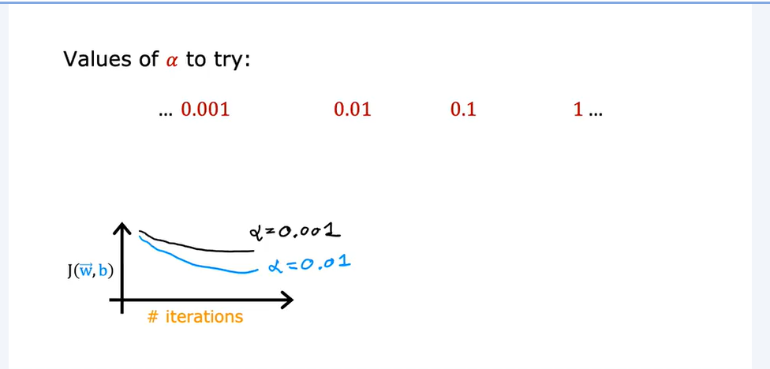

If learning rate is very big then the global minima of cost function can not be found and if it is very low then the model will learn very slowly and it will take much more time which is inefficient

With a small enough alpha , J(w,b) should decrease on every iteration.

Feature Engineering :

**Feature Engineering** is the process of **creating, transforming, or selecting the most relevant features** (input variables) from raw data to improve the performance of a machine learning model.

**Why is Feature Engineering Important?**

* Models are only as good as the **input features**.
* Better features → Better predictions (even with simple models).
* Helps the model **learn patterns** more easily.

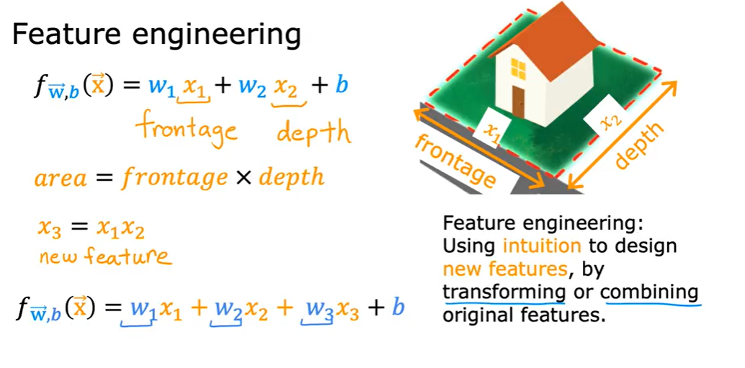

Feature Engineering = Smart transformation of raw data into meaningful inputs that boost model performance.

Classification:

**Classification** is a type of **supervised learning** where the goal is to predict **discrete labels** (categories) for input data.

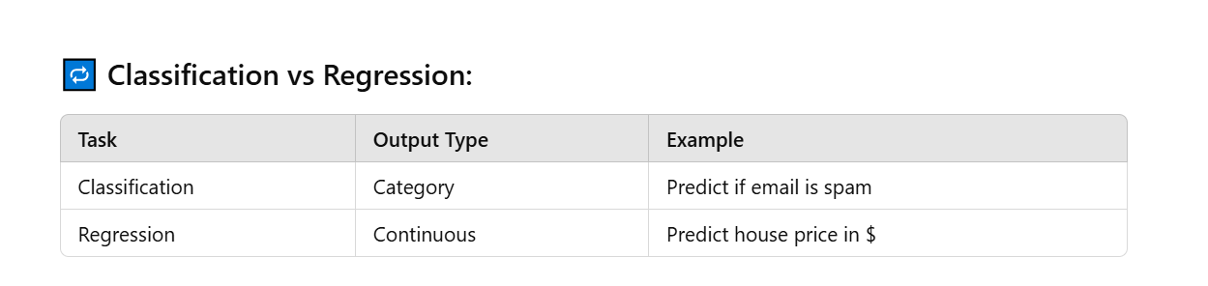

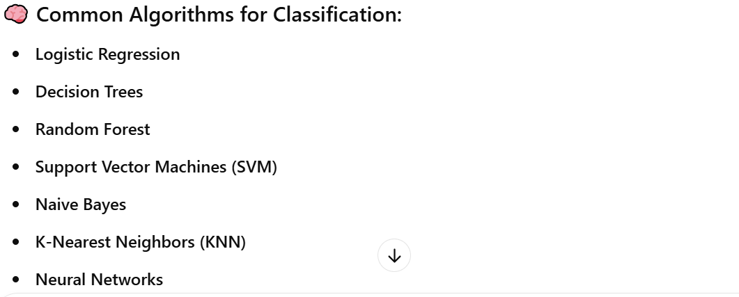

Evaluation metrics:

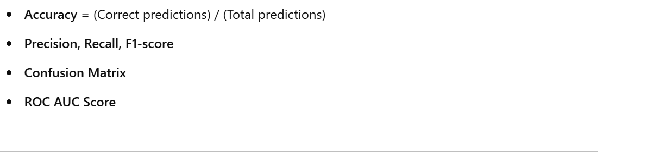

Logistic Regression:

**Logistic Regression** is a supervised machine learning algorithm used for **binary** (and sometimes **multi-class**) classification tasks. Unlike linear regression which predicts a continuous output, **logistic regression predicts the probability of a class label (0 or 1)**.

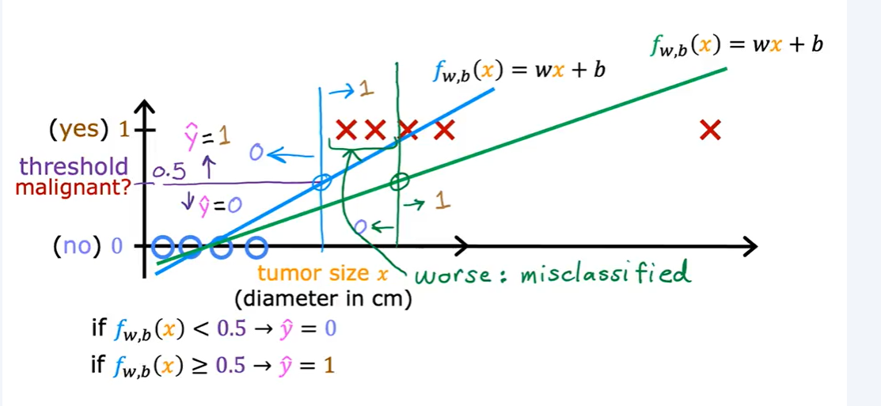

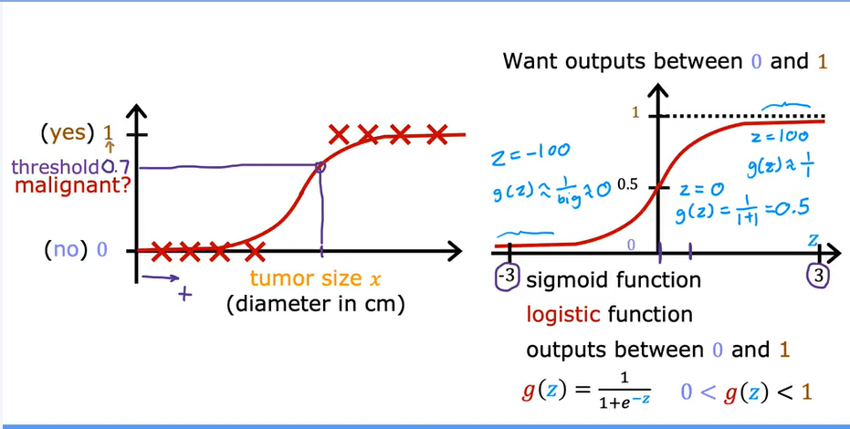

At the heart of logistic regression is the **sigmoid (logistic) function**. This function squashes any real-valued number into the range (0, 1), making it suitable to interpret as a **probability**.

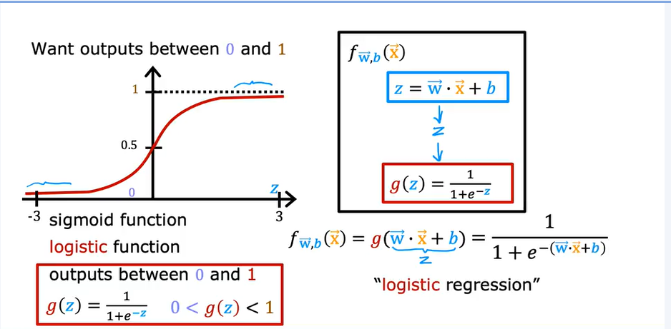

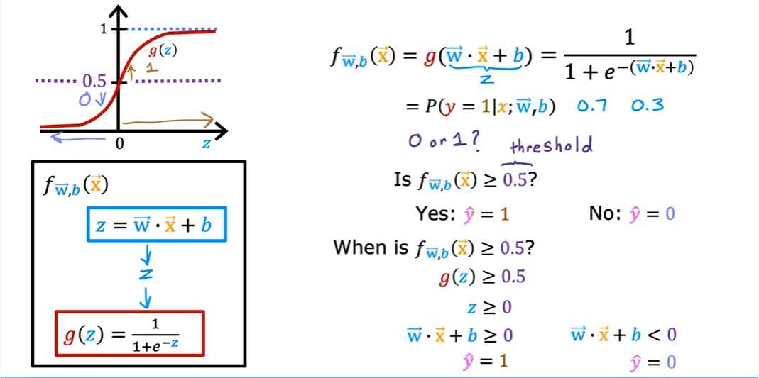

When wx+b >=0 the model predicts 1 and when wx+b<0 the model predicts 0.

Cost Function For Logistic Regression:

The cost function tells us **how well our logistic regression model is performing**. We want to **minimize** this cost during training using optimization (like gradient descent).

Cost function for logistic regression:

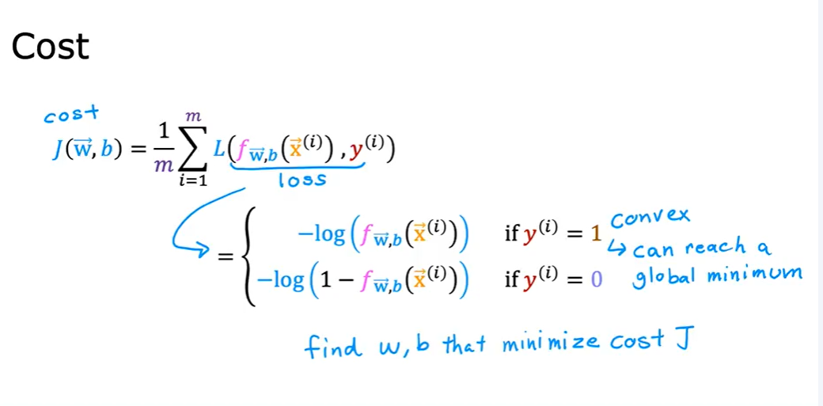

Gradient Descent for Logistic Regression:

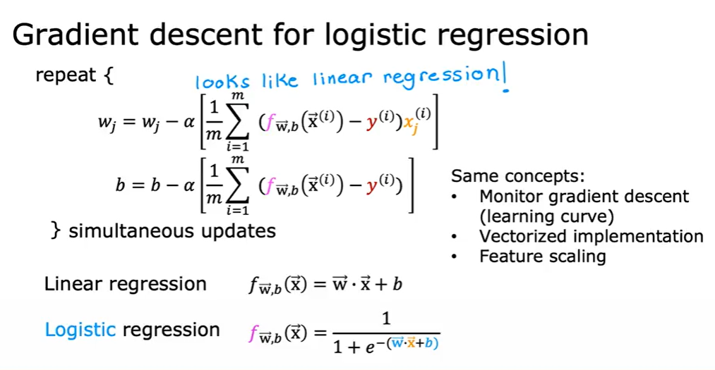

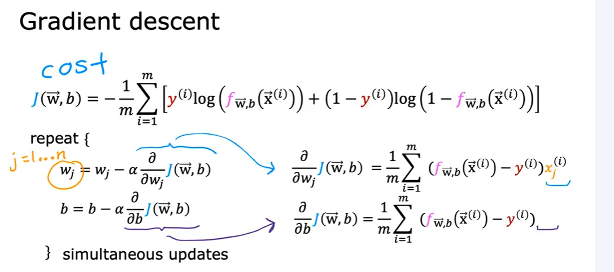

Problem of Overfitting:

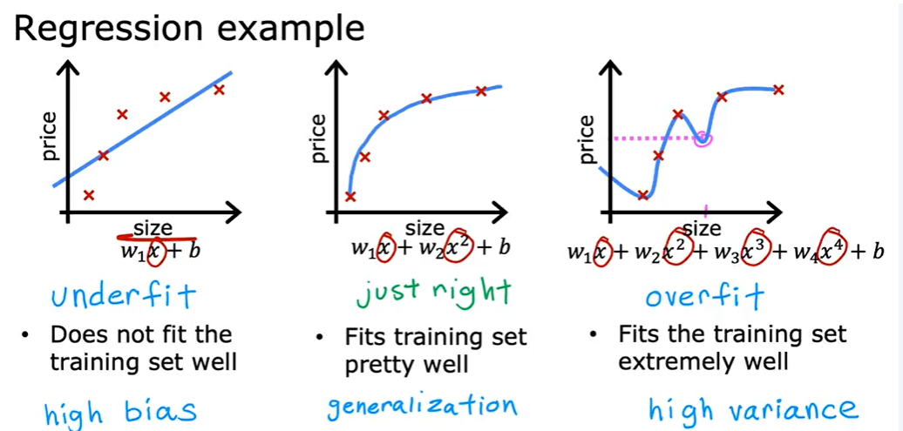

Overfitting : **Overfitting** is a common problem in machine learning and statistical modeling where a model **learns the details and noise** of the training data to such an extent that it **negatively impacts the performance** of the model on new data (i.e., it generalizes poorly).

Underfitting: **Underfitting** is the opposite of overfitting. It occurs when a model is too **simple** or **too weak** to capture the underlying patterns in the data. An underfitted model will perform poorly on both the training data and new (test) data because it fails to learn the relevant structure in the data.

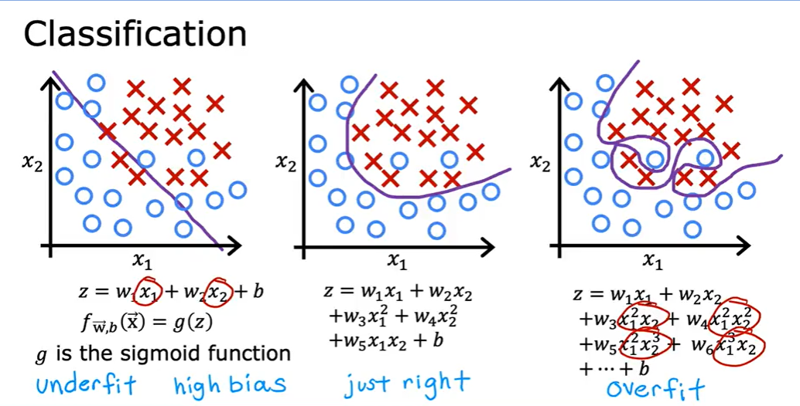

Addressing Overfitting:

Solution to overfitting:

1. Collect more training examples:

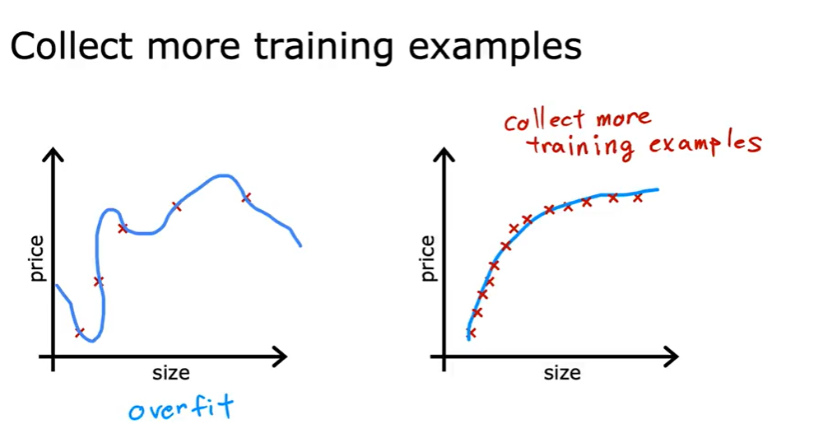

1. Select features to include and exclude:

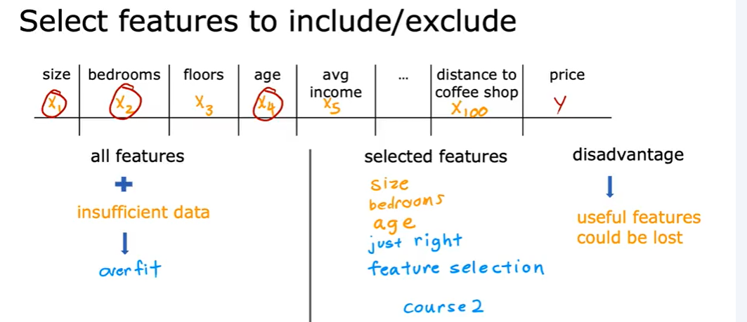

1. Regularization:

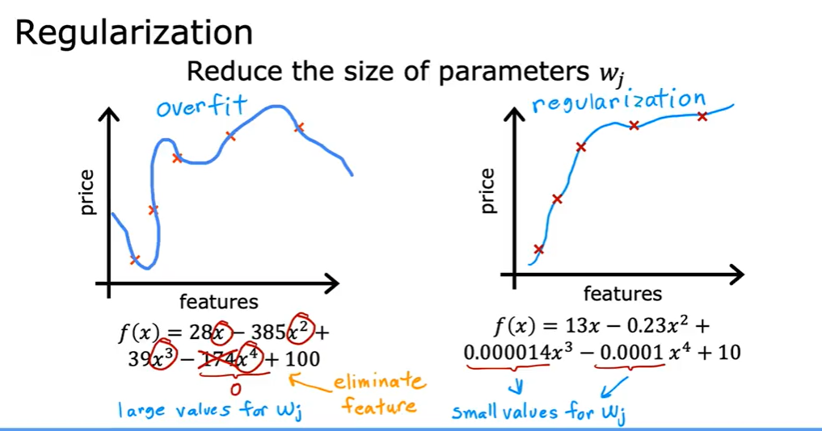

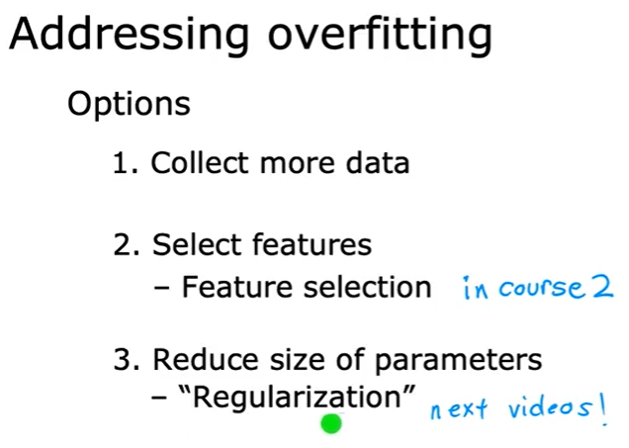

Regularization: **Regularization** is a technique used to **reduce overfitting** by adding a penalty to the loss function, discouraging overly complex models.

**L1 Regularization (Lasso)**: Adds the absolute sum of weights as a penalty and can perform feature selection.

**L2 Regularization (Ridge)**: Adds the squared sum of weights as a penalty and helps prevent large weights but doesn't eliminate them.

**Elastic Net**: A combination of L1 and L2 regularization.

Cost Function with Regularization:

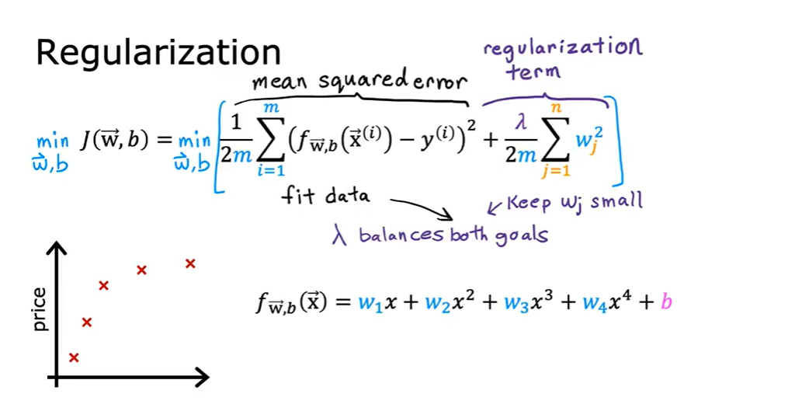

Regularized Linear Regression:

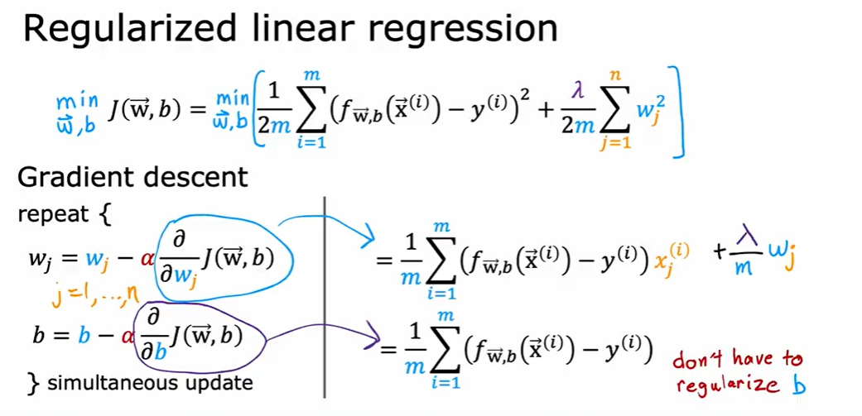

Implementing gradient descent with regularization:

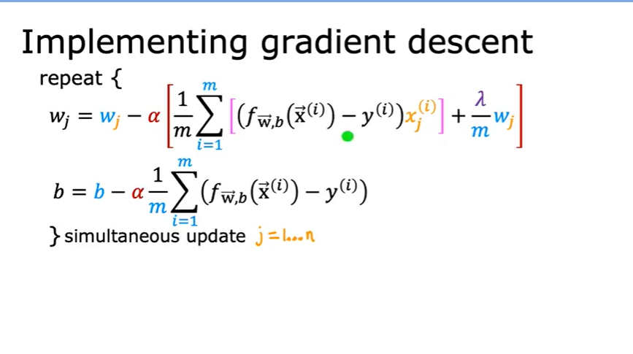

Regularized Logistic Regression:

